## Work instruction BLT Distributor Maintenance

**____________________________________________________________________**

1. Objectivez : - Safe maintenance of BLT distributor.
2. Scope : - Blast Furnace Accessories
3. Ref. : -
4. Responsibility : - Engineer In charge & Maintenance Fitter on job

PPE –s to be used :

* Helmet, CO monitor, dust mask, Safety shoes, hand gloves and complete sealed goggle
* Work No 1 : Beta & alpha drive gear box /motor replacement
* Work No 2 : Beta drive gear box oil pump replacement
* Work No 3 : Replacement / Inspection of grease hoses ,rollers ,gear & lubrication of main gear
* Work No 4 : Replacement of N2 hose.
* Work No 5 : BLT chute replacement.
* Work No 6 : Distributor replacement.
* Work No 7 : Distributor Back flushing.

Aspect- Impact

Scrap generation Resource Depletion

|  |  |
| --- | --- |
| Oil & Grease spillage | Land contamination & Resource Depletion |
| Fumes | Health |

Hazards identified

Mechanical hazard - Fall of flange, bolts, wedges, rod etc from height.

### Fall of person due to grease & oil spillage on platform

Collision with structure due to lower head room.

Fall of chute changing equipment, failure of trolley, chain pulley block & sling.

Fall of person from platform due to furnace back fire

Fall due to trapping between objects due to poor housekeeping

Non usage of PPE, violation of SOP, horse play, under influence of alcohol

Physical Hazard Explosion, Fire, Temperature, Pressure

Chemical Hazard - Gas poisoning.

Electrical Hazard Electric shock

Human Behaviour - Workmen under influence of alcohol

Violation of procedure

Not wearing PPE’s

Not concentrating while working

Horseplay

Work No 1 : Beta & Alfa drive gear box /motor replacement

1. Take Electrical shut down and take clearance from production SS for working at furnace top by taking work permit.
2. Do carry 2 nos of CO detectors and monitor it continuously.
3. Request electrical to disconnect the cables and take electrical shutdown
4. Remove the electrical connection (Cable),Loosen the flange bolts of respective gear box/motor.
5. If GB having leakage same oil to be drain first from drain plug before removing GB.
6. Using 1” manila rope / chain block 2T/ wire rope sling 1m 2 nos/ D shakle 1 ton 2 nos/
7. to lift the gear box /motor to be replaced & keep it aside by using Using slowly lower the gears box/motor to its position by using & tighten the flange bolts.
8. Ensure sufficient oil/Grease is available in gear box.
9. Key way to check properly if find worn out same to replace
10. Request electrical to be connect the cables.
11. Clear electrical shutdown & request control room in charge to take trial.
12. Check for any abnormal sound during operation.
13. Clear work permit.
14. Ensure housekeeping is carried out.

**Work No 2: Beta drive gear box oil pump replacement**

1. Take Electrical shut down and Take clearance from production SS for working at furnace top by taking work permit.
2. Do carry CO detector and monitor it continuously.
3. Take electrical shutdown & request electrical to disconnect the cables.
4. Drain the oil from the gear box, by collecting in suitable container.
5. Replace the pump assembly with spare unit
6. Replace the O ring of pump and GB flange if required.
7. Re fill the oil in the gear box, and ensure sufficient level is maintained.
8. Request electrical to connect the cables & clear the shutdown for trials.
9. Ask control room in charge to take trial, by starting the Beta drive.
10. Check for any oil leakage.
11. Clear the work permit and give clearance.

11. Ensure housekeeping is carried out.

**Work No 3:Replacement / Inspection of grease hoses , rollers, gear & lubrication of main gear.**

1. Take Electrical shut down of Beta & Alpha drive, and Take clearance to work at furnace top by taking work permit.
2. This job has to be done only during furnace shutdown.
3. Ensure top firing is carried out by operation dept.
4. Close the nitrogen valve & and ensure that water cooling is continuously ON.
5. Request control room in charge to monitor distributor temperature continuously.
6. Open the side inspection door of distributor.
7. Using Torch inspect the gear for any abnormality.
8. Manually apply grease to main gear.
9. All arms to be manually greased using grease gun.
10. Check for all drain points of water jacket for any blockage.

(All drain points should be free; else water can enter into the furnace).

1. Inspect the rollers for any wear. In case any abnormality is noticed same to be replaced with spare ones, by loosening the lock nuts.
2. Check the roller slide frame for proper lubrication

(Slide frame has small holes from which grease ooze out during normal lubrication cycle. )

1. Check grease hose for any puncture, else same to be replaced by isolation of lubricating valve.
2. Close the inspection door.
3. Open the Nitrogen valves by clearing the Mechanical isolation.
4. Clear electrical shutdown & work permit.
5. Give clearance.

**Note**: If Beta drive has to be inspected by keeping the distributor inspection door open then proper care should be taken by ensuring that people are standing away from the rotating equipment and watching from the inspection door.

**Work No 4: Replacement of N2 hose**.

1. Take clearance to work at furnace top by taking work permit.
2. This job has to be done only during furnace shutdown.
3. Take electrical shutdown of Beta & Alfa drive.
4. Ensure top firing is carried out by operation dept.
5. Close the nitrogen valve & take mechanical isolation and ensure that water cooling is continuously ON.
6. Request control room in charge to monitor distributor temperature continuously.
7. Open the side inspection door of distributor.
8. Take electrical shutdown of Grease lubrication system & take mechanical isolation.
9. Now replace the damaged hose with 1/2' hose of 750 mm length by using adjustable spanner.
10. Ensure to replace the O rings to prevent any leakages.
11. Clear the shutdown of lubrication system and take trial , if no leakages are noticed , then close the inspection door of distributor .
12. Clear the electrical shutdown of Beta & Alfa drive .
13. Clear the mechanical isolation of nitogen line and open the valves.
14. Clear the mechanical isolation of grease lubrication system.
15. Clear the work permit and give clearance to operation dept.

**Work No. 5 : BLT chute replacement**

1. Take Electrical shut down of Beta & Alpha drive after proper positioning chute towards top hatch side Take clearance from control room in charge for working at furnace top by taking work permit. This job is done in shutdown only.
2. Ensure no parallel activity like tuyere replacement or cooler replacement is underway at the same time while chute replacement is going on.
3. Ensure top firing is carried out. Ensure no material in burden tank and charging hopper.
4. Carry two Nos CO Monitors and ensure gas level below 50PPM
5. All tuyeres should be plugged and ensure no suction of air from tuyeres.
6. Ensure Lower sealing Valve in close condition & take mechanical isolation of powerpack.
7. Dismantle the chute changing hatch (under the top firing door) taking the load by over head fitted chain pulley block trolley & removing the cotter & pins of hatch door by using hammer.
8. Once all pins are removed , dismantle the main rectangular hatch and keep it aside .
9. Ensure to keep the chute’s face towards the chute changing hatch, if it is not there than rotate the chute & position it as shown below .

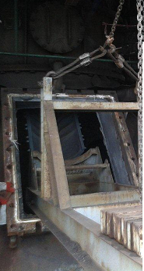

1. Set the chute angle to 34 degree .
2. Open the opposite side manhole (BLT lubrication pump side) for better visibility & cover it with mesh.
3. Now support the chute replacement device by using 5 ton chain blocks 1 nos/ 2 Ton chain block 1 nos/ wire rope sling 1 m 4 nos, D shakle 2 ton 4 nos/ as shown in below photo.

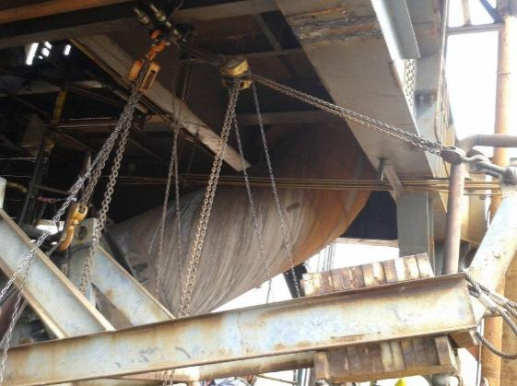 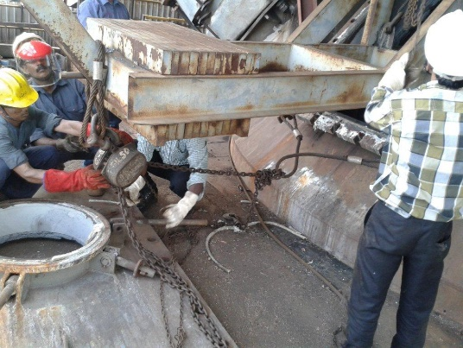

1. Rest the existing chute on the chute changing device as shown below by adjusting chain pulley blocks and ensure the chute is locked in the arrangement by viewing from opposite inspection door.

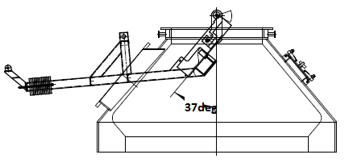

1. Now slowly move the replacement device ( by adjusting chain blocks) upward along the inner wall of the racket , so that the chute pin gets separated from the racket arm
2. Small flange opening is fabricated as shown below in diagram to check weather the pin is getting properly lock in racket arm.
3. Now slowly decrease α angle say 25 deg as per the requirement keeping a close watch at the trunion point so that chute pin is completely separated from the racket arm as shown below.

Extra flange opening given for chute p in locking inspection during installation and removing chute

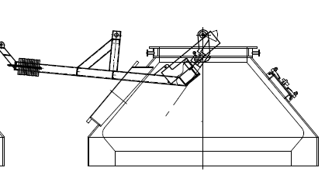

1. Once it is confirmed that chute is disengaged from racket arm , using chain blocks , take out the replacement device along with removed chute.

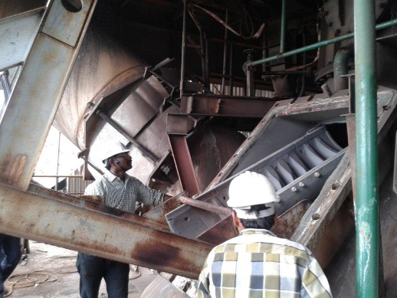

Note : For fixing the chute , follow reverse of dismantling steps .

17.Afterwards take trial by clearing Mechanical isolation.

**Work No. 6 : BLT DISTRIBUTOR REPLACEMENT.**

Note **:** The above activity to be carried out in furnace shutdown.

|  |  |  |  |  |  |  |
| --- | --- | --- | --- | --- | --- | --- |
|  | **DISASSEMBLY ACTIVITIES.** | |  | |  | |
|  | 1. Take Electrical shut down of Beta & Alpha drive, and request to disconnect the cables, Take clearance from production SS for working at furnace top by taking work permit | |  | |  | |
|  | 1. Do Carry 2nos CO detector and monitor it continuously. | |  | |  | |
|  | 1. After production clearance, Top hatch to be opened and top firing by operation. | |  | |  | |
|  | 1. Remove Distributor chute and keep it aside. | |  | |  | |
|  |  | | | | | |
| 1. Take electrical shutdown for Lubrication pump and BLT powerpack & take mechanical isolation. | |  | |  | |
|  | |  | |  | |
| 1. Inform instrumentation to disconnects the cables of alfa and beta drive. | |  | |  | |
| 1. Inform instrumentation to park the stock rod 1&2 heavy bob at maintaintence position and disconnect cables. | | | | | |
| 1. Take electrical shutdown for Stock rod 1&2 and request electrical to disconnect the cables, | | | |  | |
| 1. Loosen the flange bolts of Beta and Alfa drive gearbox and motor. | |  | |  | |
| 1. Remove the Beta and Alfa drive gearbox and motor by using chain pulley 2T block and keep it at crown ring platform. | | | | | |
| 1. Loosen the flange bolts of stock rod 1&2 drive gearbox and motor | |  | |  | |
| 1. Remove the stock rod 1&2 drive gearbox and motor by using chain pulley block and keep it aside. | | | |  | |
| 1. Remove the stock rod assembly 1&2 by using chain pulley block 5T/ wire rope sling 5T and keep it aside. | | | |  | |
| 1. Remove the Expansion bellow by using chain pulley block 5T / wire rope sling 5t and keep it at crown ring platform | | | |  | |
|  | |  | |  | |
|  | | | | | |
| 1. Isolate all water and Nitrogen valves of the distributor. | |  | |  | |
| 1. Disconnect all water, Nitrogen and Lubrication lines of the distributor . | |  | |  | |
| 1. loosen the base bolts of distributor. 2. Remove the distributor using chain pulley block 5ton 4 nos / wire rope sling 5 ton 4 nos/ D shakle 5 ton 4 nos and monorail and keep it at crown ring platform towards SGP side. | |  | |  | |
|  | | | | | |
| 1. Shift distributor from crown ring platform to ground level using 200T Crane | |  | |  | |
|  | |  | |  | |
| **ASSEMBLY ACTIVITIES** | |  | |  | |
| 1. Shift New distributor from ground level to crown ring platform using 200T Crane | |  | |  | |
| 1. Place the distributor above crown ring using chain pulley block 5ton 4 nos / wire rope sling 5 ton 4 nos/ D shakle 5 ton 4 nos and monorail. | |  | |  | |
| 1. Tighten the base bolts of distributor. 2. Distributor spare chute placement. | |  | |  | |
|  | |  | |  | |
|  | |  | |  | |
| 1. Position the Expansion bellow with liner by using chain pulley block . | |  | |  | |
| 1. Tighten the bolts of expansion bellow | |  | |  | |
| 1. Position the Stock rod assembly 1&2 using pulley block 5T / wire rope sling 5t | |  | |  | |
| 1. Position the Stock rod assembly 1&2 drive gearbox and motor using pulley block 5T / wire rope sling 5t. 2. Both stock rod calibration taken. | |  | |  | |
|  | |  | |  | |
| 1. Position the Alpha and Beta drive gearbox and motor using chain block 2 T/ wire rope sling 1 m 1 nos. | |  | |  | |
| 1. Ensure sufficient oil is available in Alpha and Beta Gearbox. | |  | |  | |
| 1. Connect all the water, Nitrogen and lubrication lines to the distributor | |  | |  | |
| 1. Inform electrical for connecting power supply cables for Alpha, beta drive, stock rod drive 1&2 and BFRV. | | | | | |
| 1. Inform instrumentation to connect the cables of alpha and beta drive. | |  | |  | |
| 1. Inform instrumentation to connect the cables of stock rod 1&2. | |  | |  | |
| 1. Clear all electrical shutdowns for taking trials. | |  | |  | |
| 1. Stock rod 1 &2 calibration needs to be done. | |  | |  | |
| 1. Check all water and lubrication valves are in open position. | |  | |  | |
| 1. Request control room in charge to take trials. | |  | |  | |
| 1. Check for any abnormal sound during operation. | |  | |  | |
| 1. Take shutdown of distributor for assembly of chute. | |  | |  | |
| 1. Clear all electrical shutdowns. 2. Clear the mechanical isolation. | |  | |  | |
| 1. Request control room in charge to take trials. | |  | |  | |
| 1. Close Top firing hatch cover. | |  | |  | |
| 1. Clear all work permit. | |  | |  | |
| 1. Ensure housekeeping is carried out. | |  | |  | |

* Work No 7 : Distributor Back flushing.

The above activity to be carried out during furnace in shutdown condition.

1.Open the water seal drain valve of distributor situated near hearth.

2.Open the backflushing water line valve of distributor .

3. Flush the distributor till internal of distributor get flushed thoroughly so that spilled grease particles /dust particles should go out from the distributor.

4. close the water seal drain valve.

5. close the backflushing water line valve

6. CO monitor to carry during back flushing of U seal.

DO:

* Monitor Co levels continuously.
* Wear Apron and face shields while working near Top hatch
* Ensure to carry at least 2 CO detectors while working at furnace top.

DO NOT:

* Open inspection door before closing Nitrogen valves & before isolating electrical supply of Beta & Alfa drive.
* Operate the Alfa drive or Beta drive when chute replacement device is engaged with the chute.
* **Amendement Record**

|  |  |  |  |
| --- | --- | --- | --- |
| **Date** | **Manual Section Ref. & Para** | **Brief details of Revision** | **New Rev.** |
| **12.04.2023** | Beta & Alfa drive gear box /motor replacement | GB having leakage same oil to be drain first from drain plug before removing GB.  Key way to check properly if find worn out same to replace | 05 |
| **12.04.2023** | **Beta drive gear box oil pump replacement** | Replace the O ring of pump and GB flange if required | 05 |
| **12.04.2023** | **BLT chute replacement** | Take Electrical shut down of Beta & Alpha drive after proper positioning chute towards top hatch side | 05 |
| **12.04.2023** | **BLT chute replacement** | Small flange opening is fabricated as shown below in diagram to check weather the pin is getting properly lock in racket arm. | 05 |
| **12.04.2023** | Distributor Back flushing. | CO monitor to carry during back flushing of U seal. | 05 |  |
|  |  |  |  |  |
|  |  |  |  |  |
|  |  |  |  |  |
|  |  |  |  |  |
|  |  |  |  |  |
|  |  |  |  |  |

|  |  |  |
| --- | --- | --- |
| **Prepared By:**  Digital head VAB | **Reviewed & Issued By:**  Management Representative | **Approved By:**  Mechanical and Asset Integrity Head VAB |
| **Signature:** | **Signature:** | **Signature:** |
| **Review Date: 12.04.2023** | **Review Date: 12.04.2023** | **Review Date: 12.04.2023** |